15.79: a) 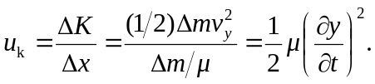

b) 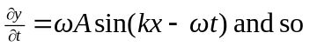

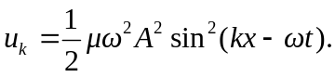

c) The piece has width 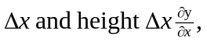and so the length of the piece is

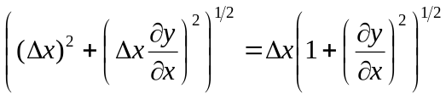

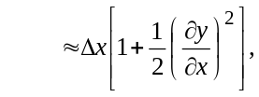

where the relation given in the hint has been used.

- 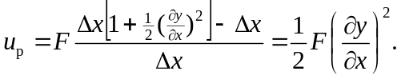
- 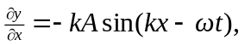and so

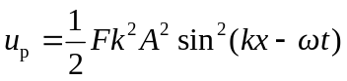

and f) comparison with the result of part (c)with 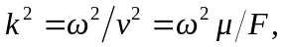 shows that for a sinusoidal wave 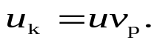 g) In this graph, 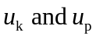 coincide, as shown in part (f).

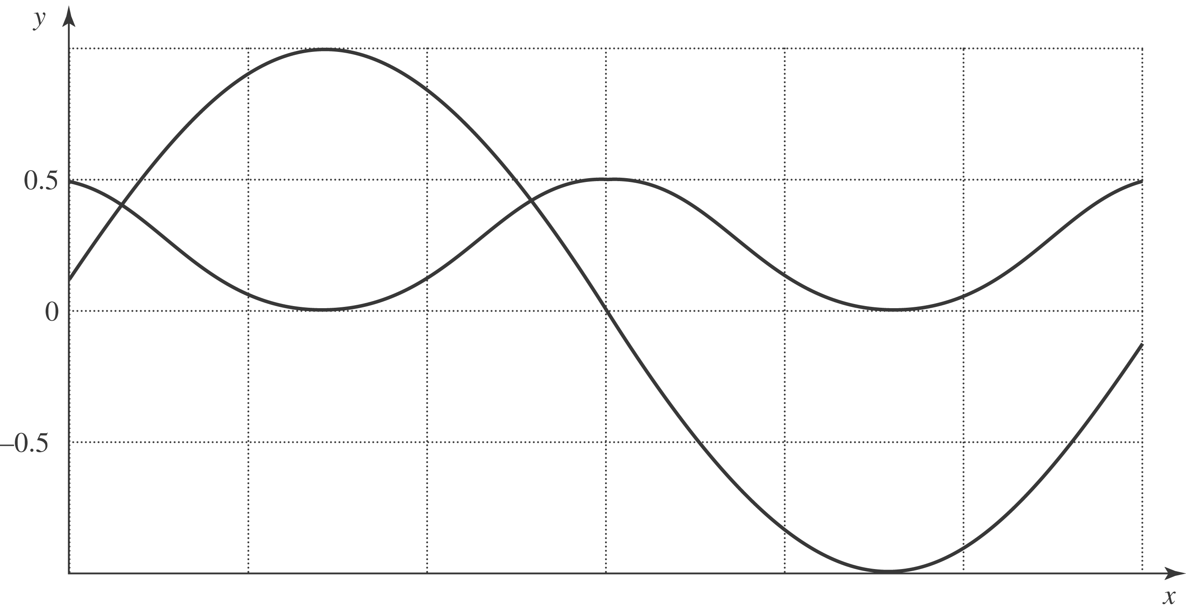

At 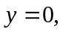 the string is stretched the most, and is moving the fastest, so 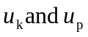are maximized. At the extremes of y, the string is unstretched and is not moving, so 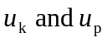 are both at their minimum of zero.

h) 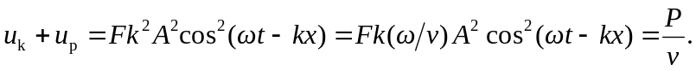

The energy density travels with the wave, and the rate at which the energy is transported is the product of the density per unit length and the speed.

